FACILITIES AND OTHER RESOURCES

[See NIH instructions in comment]

Scientific Environment
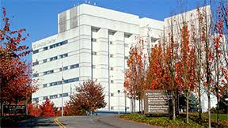
VA Puget Sound Health Care System provides a strong research environment with multiple opportunities for collaboration and support that will contribute to the success of the proposed study. The local VA R&D program is the 5th largest in the VA, with over 750 active research projects, reflecting VA Puget Sound’s commitment to the vital role that research plays in the VA mission. In March 2019, the facility opened a new 220,000 square foot Mental Health and Research Building, further raising the profile of research on campus and demonstrating the institution’s commitment to research as a component of world-class care. VA Puget Sound’s academic affiliation with the University of Washington further expands and strengthens the local expertise and support for research available to this project.

Physical Resources
VA Puget Sound provides strong research support with use of research facilities, performance of clinical labs, and lab and office space for investigators and study staff. [Describe what is needed that you already have access to for the proposed project. Requests for additional space/staff support will need to be reviewed by the facility.]

Clinical
[Describe as applicable – address size and availability of target participant population if applicable]

Clinical Research Unit (CRU) is a VA Puget Sound facility that provides expert clinical services for VA research on a fee-for-service basis. The CRU is located at the VA Puget Sound Seattle campus, on the fifth floor in the new Mental Health Research Building 101. [Can delete items below not applicable to the proposal]
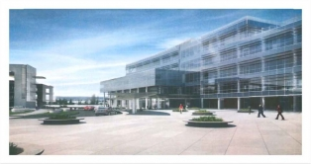
The CRU covers 5,641 square feet and includes:

3 Exam rooms
2 Single-bed procedure/observation rooms
2 Double-bed procedure/observation rooms
1 Interview/conference room
2 Observation/Nursing Stations
1 Physiology (exercise/training) room
1 Lab/sample processing room
1 Phlebotomy room
1 Kitchen
4 Bathrooms

Omnicell pharmacy unit
ParEx supply and distribution system
EKG Machines
Refrigerated Centrifuge
Hologic bone densitometer (DEXA)
-80-degree freezer storage

For this proposal, the CRU will perform [list procedures].

Laboratory
[Describe as applicable]

Animal
If applicable - VA Puget Sound has an AAALAC-accredited animal facility that supports vital research requiring animal models. The facilities and the program comply fully with the Animal Welfare Act and US Public Health Service Policy on humane care and use of laboratory animals. The program is managed by specialty-certified veterinarians and animal care staff. The R&D animal ethics committee (IACUC) oversees the program and reviews research protocols and ongoing work.

Computer
[Describe as applicable]

Office
[Describe as applicable]

Other
[Describe as applicable]

Administration (for SIBCR proposals)
Dr. [PI name] is or If this proposal is funded, Dr. [PI name] will become a member of the Seattle Institute for Biomedical and Clinical Research (SIBCR), a nonprofit corporation whose mission is to improve the health and well-being of Veterans through research and education conducted at the VA Puget Sound Health Care System and Mann-Grandstaff VA Medical Center. SIBCR will provide resources such as grant and budget management, accounting, and HR support for SIBCR employees through an established, proven administrative infrastructure.

